Orators Report
on the 13th Degree
Royal Arch Of Solomon

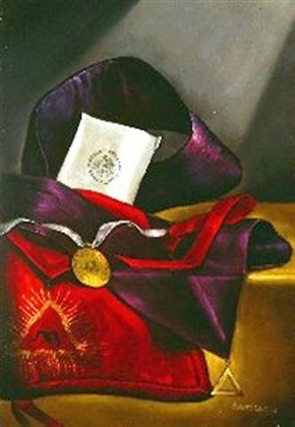

The apron of the 13th Degree is crimson red with a mixture of blue, symbolizing zeal, and includes the rayed triangle, the emblem of Deity and Light. In the center is an ancient form of the Hebrew letter yod.

Bremerton Valley of the Scottish Rite
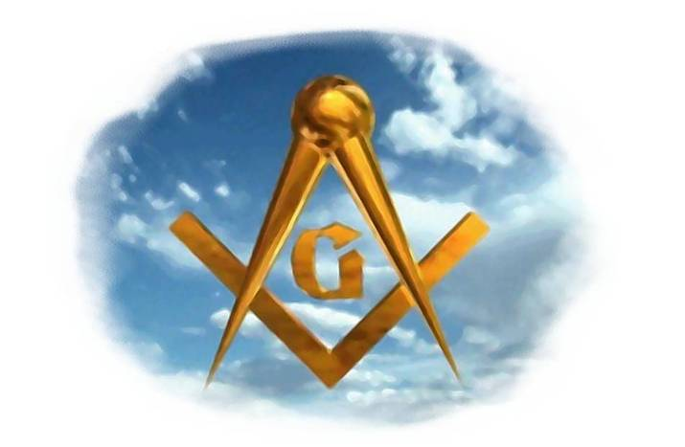
The Legend: The LOP Rites are based largely upon the Hiramic legend that follows after Hiram Abiff's death. The thirteenth degree was also called the Royal Arch Of Enoch. This degree is also the climax of the ineffable degrees and is a preparation for the "Degree of Perfection" which follows. The ancient mythical Legend found in the old Rituals is based on Genesis 5, is as follows:
Enoch was a man of exceptional virtue. Seeing this, God revealed His true name to Enoch in a vision. Enoch took the dream as a sign from God and after a long journey through the Holy Land, he excavated nine apartments vertically into the earth, each covered with an arch. In the lowest apartment he placed a pedestal and mounted upon it a cube of agate into one side of which he had sunk a triangular plate of gold inscribed with the name of Deity. Above the apartments he built a modest temple.
During the construction of King Solomon's Temple an administration center was needed. The site chosen for this center was unknowingly that of Enoch's original temple. During the removal of the ruins, the secret passage was discovered. Adoniram and two of his assistants (YehuAber and Satolkin) successively lowered each other into the dark vertical passage. Adoniram finally reaches the ninth apartment and discovers the treasure and the Lost Word.
The Setting: The Audience Chamber of King Solomon, its hangings, decorations, and arrangements being the same as the Ninth Degree. There is also a darkened apartment representing the subterranean vault.
The Ritual: King Solomon, styled Venerable Master, directs three candidates, representing Adoniram, YehuAber and Satolkin, to descend into the ruins of the darkened shaft. After great effort, they arrive at a scene representing the interior of the lowest arched vault, a Brother lifts the cloth that covers the pedestal and discloses the cubical stone. The darkened scene is brightly illuminated and a voice offstage says: "... mortals: adore the great ineffable name of God!" The three take the cubical stone from the pedestal, are drawn up, one after the other, and return to King Solomon's Audience Chamber. There, the candidates are made Masons of the Royal Arch of Solomon and taught the lessons of the degree.
The candidates are invested with the cordon, jewel, and emblem of the degree. Upon the face of the jewel is a representation of the first three recipients of this Degree, two of them lowering the third into the subterranean vault. On the reverse side is the luminous triangle, and the first letter representing the Hebrew ineffable name.
The Lecture:
The political lessons taught in the degrees thus far are reviewed; we find:
Degrees Political Lessons
4th, 5th, 6th: An enlightened citizenry
7th: An independent judiciary
8th: An economic order based on capital and labor
9th: An upper house of legislation
10th: A lower house of legislation
11th: Trial by jury
12th A chief executive
13th: A constitution or fundamental law
This lecture provides foundational material for subsequent degrees and it discusses the important duties of this degree: to seek knowledge and to be motivated by honor and duty. It also teaches the progressive nature of man's awareness of God and His attributes. When a person truly begins to experience his own spirituality, a personal transformation takes place. We start to become different people, richer in spirit, more compassionate, more truly human. But it is an active search, zeal with a touch of spirituality, spirituality with a touch of zeal, that never ends as we grow closer to Deity in mind, heart, and spirit.

THE MORAL TEACHING of this degree is: Moral character is a habit, not formed in a moment, and liberty in our mind and our hearts is motivated by duty and honor.

DUTIES: Seek knowledge. Be motivated by duty and honor.

FOR REFLECTION: Whatever a man seweth, he shall reap: Are idle hours and idle words subject to this great law?

IMPORTANT SYMBOLS: Enoch, Adoniram, YehuAber and Satolkin. The vault, the cube of agate, the triangle of gold, the name of Deity. We know from the old tracing boards that the name of Deity was the Anglicized form of the Hebrew Ineffable Word consisting of three letters, one of which is repeated.

"Step where we will, we tread upon wonders. The sea-sands, the clods of the field, the water-worn pebbles on the hills, the rude masses of rock, are traced over and over, in every direction, with a hand-writing older and more significant and sublime than all the ancient ruins, and all the overthrown and buried cities that past generations have left upon the earth; for it is the handwriting of the Almighty". – Albert Pike

Adapted from the Spanish version of Rex R. Hutchen’s book A Bridge to Light

